**CP Club 365 Days Challenge**

**Programming language – C++**

**Problem Statement**

<https://www.codechef.com/problems/EVENTUAL>

Git :- <https://github.com/Vedantbharad2603/CP_club_365_Days>

**Your Code**:

**Output (Screen Shot)**:

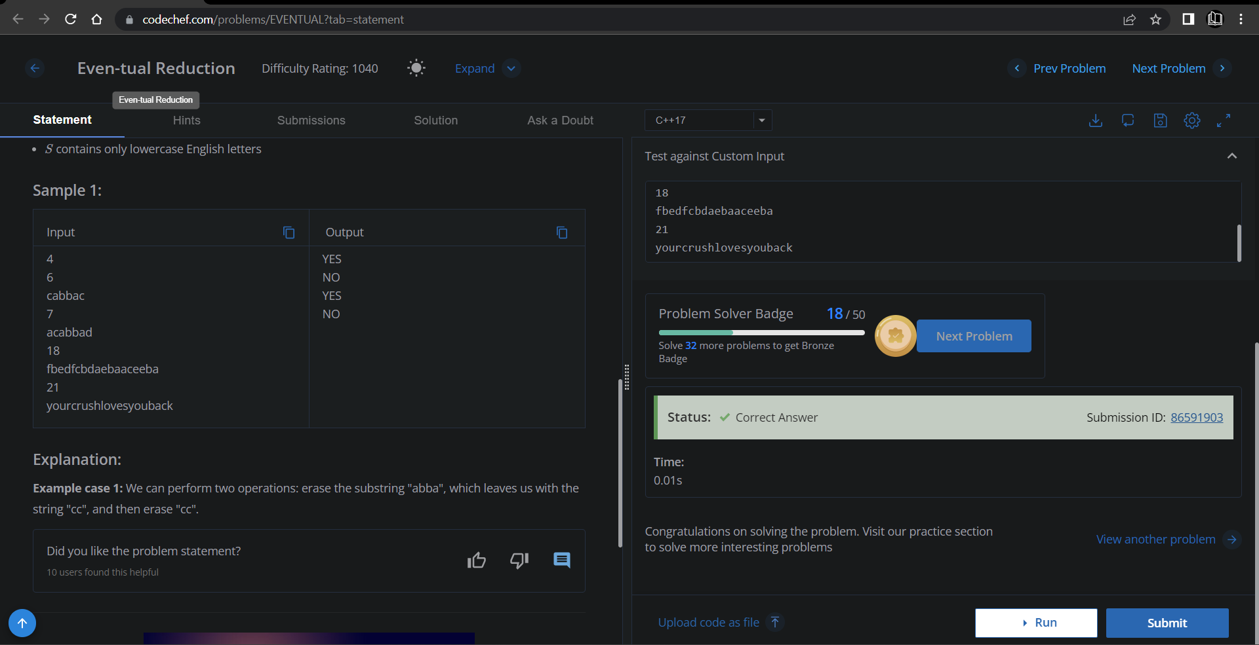

**Understanding about problem:**

Note: If you can't understand the problem, feel free to contact us and we'll help you. Please don't copy and paste from anywhere.

ALL THE BEST

Team CP Club